Project Design Phase-II
Data Flow Diagram & User Stories

Date | 2 Dec 2025
Team ID | SWUID20250174883
Project Name | Social Media App
Maximum Marks | 4 Marks

Level 0 (Context-Level DFD)
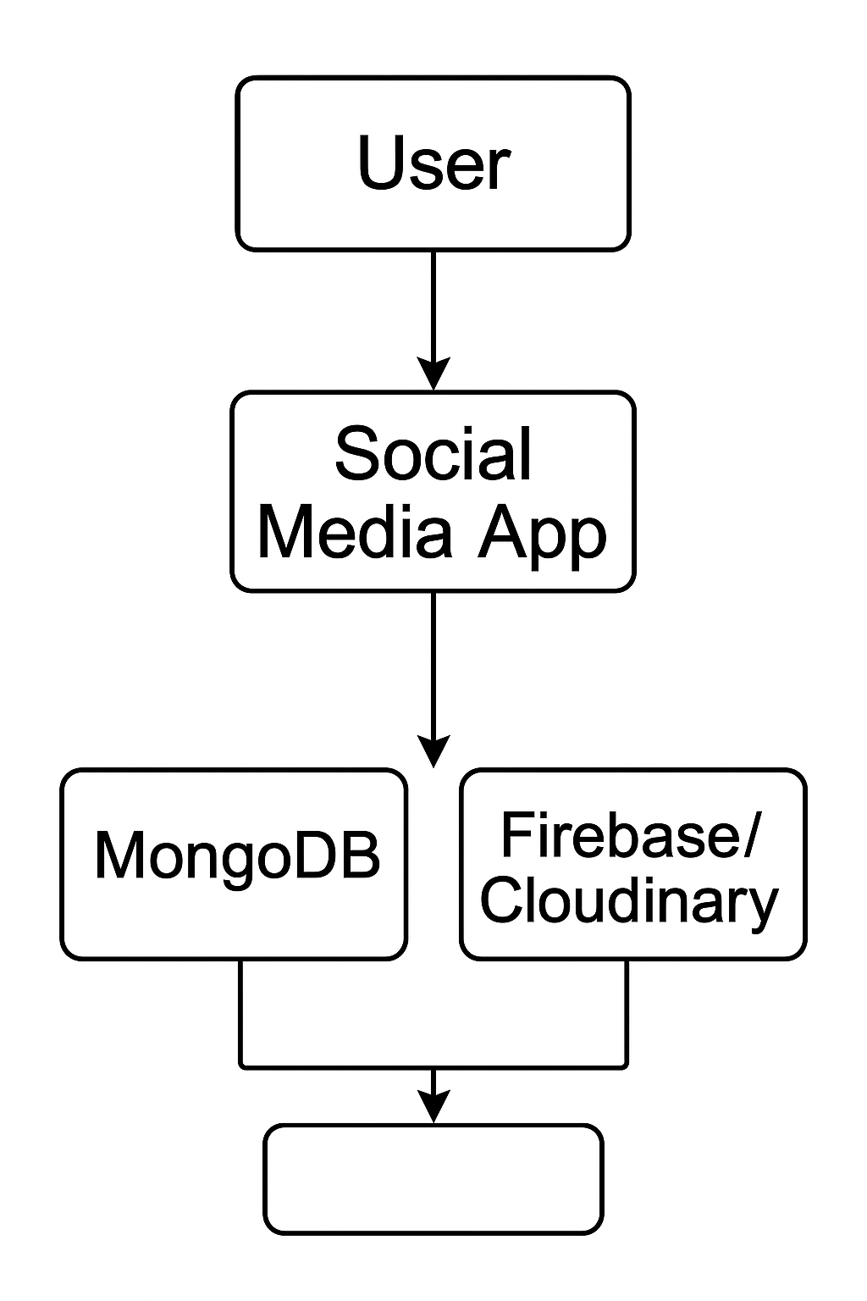
- User interacts with the app to perform actions like registration, posting, chatting.
- The Social Media App (built with MERN stack) serves as the central system.
- It interacts with:
  - MongoDB for storing user data, posts, comments, chats, etc.
  - Firebase/Cloudinary for media storage (images/videos).

Level 1 DFD (Functional Breakdown)
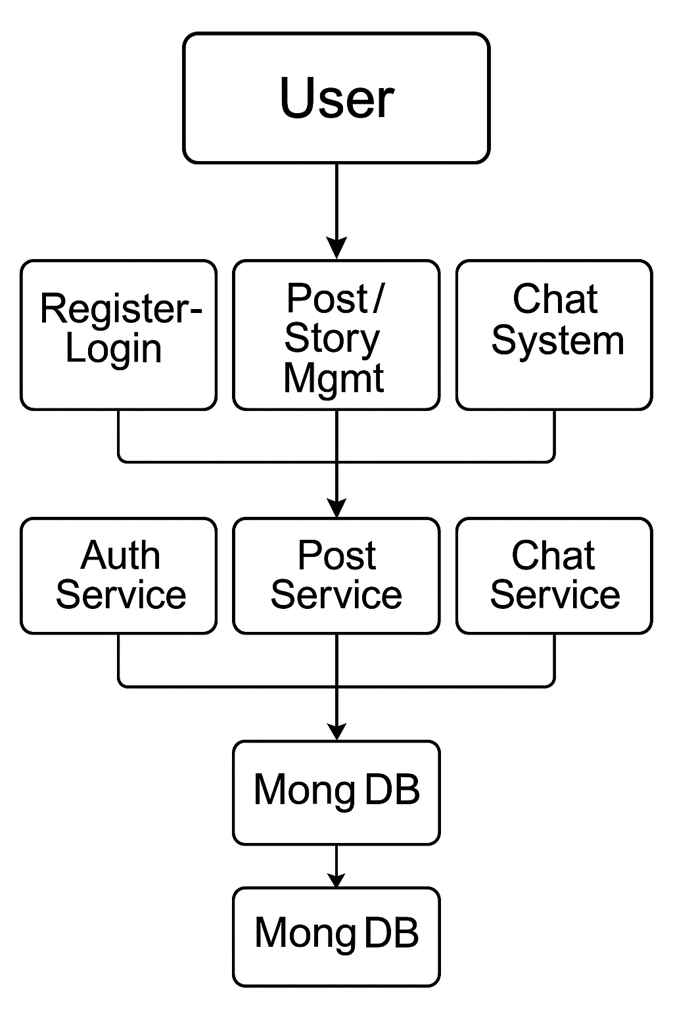
Each user action (e.g., login, chat, post) routes through dedicated services that interface with the database.

User Stories
User Story ID | As a user...
US01 | I want to sign up and log in securely so that I can access my account safely.
US02 | I want to create and view posts so I can share content with my network.
US03 | I want to comment on and like posts so I can interact with other users.
US04 | I want to upload stories that expire in 24 hours so I can share updates easily.
US05 | I want to chat in real-time so I can communicate instantly with friends.
US06 | I want to follow/unfollow users so I can manage my social feed.
US07 | I want to receive real-time notifications so I don’t miss important activity.
US08 | I want to update my profile info and picture so I can personalize my account.
US09 | I want to save posts so I can view them later when needed.
US10 | I want a fast and responsive experience on mobile and desktop.

